VLSI HW3

106061151 電機大三 劉安得

1.

Simulate the input capacitance of the first inverter

The first inverter’s Cin is 3.9284fF

1.(a)

1.(b)

tpdr

tpdf

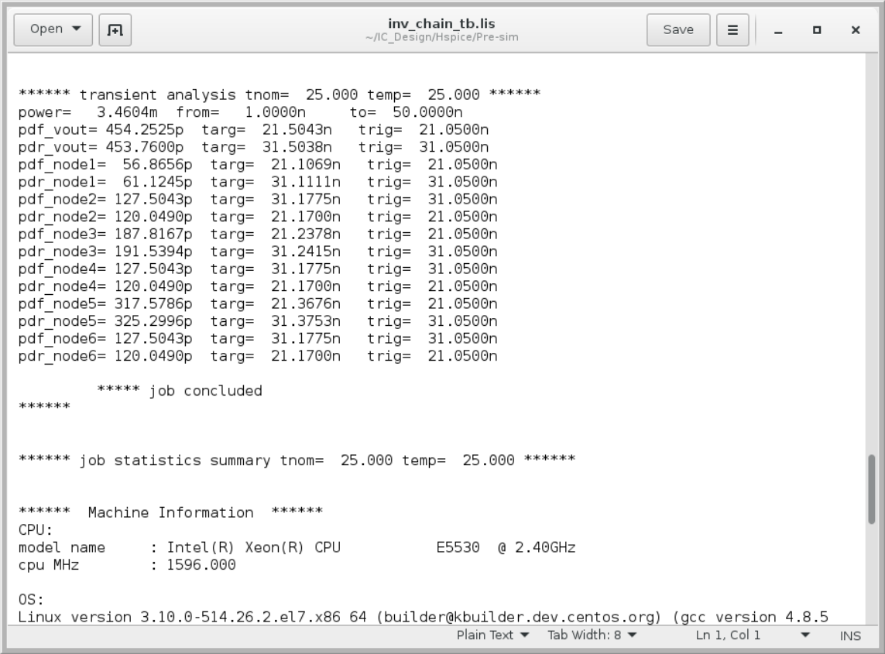

1.(c)

C(total) = Cin + Cout + Cnode1 + … + Cnode6

= 13.9382f + 46.1028f + 128.1861f + 432.6417f + 1.2254p + 4.1346p + 3.9284f + 14.4245p

= 20.4093pF

P = CV2f = 43.0441p * 1.82 * 50M = 3.3063mW

1.(d)

在1(b)的數據圖中，P = 3.4604mW，而(c)我們算得3.3063mW，誤差為4.45%。這可能是因為inverter的 α 不等於 1，因此公式要修正為 αCV2f

2.

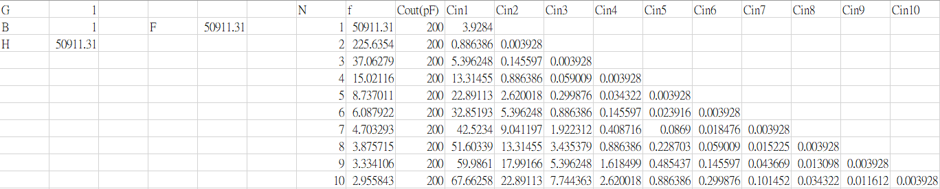

2.(1)

N = 1

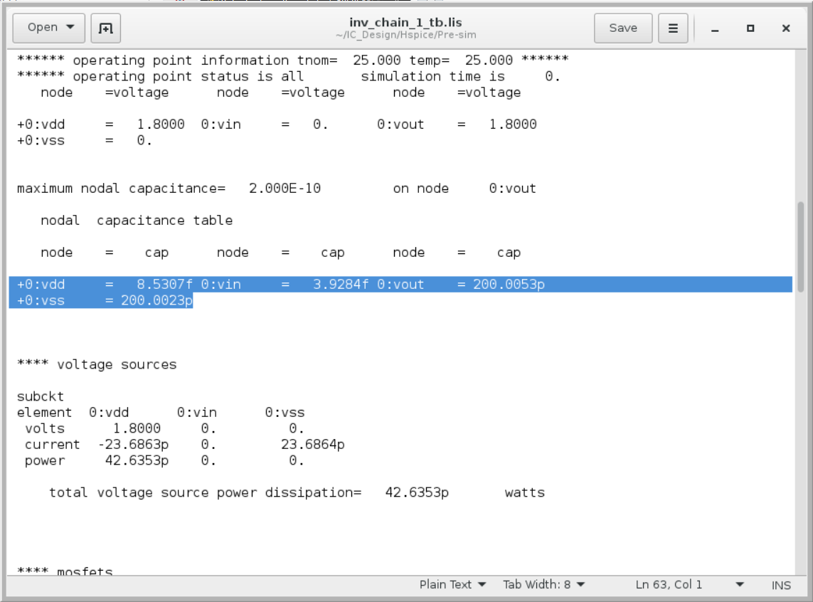

C(total) = Cin + Cout = 3.9284f + 200.0053p

= 200.0092pD

P = CV2f = 200.0092 * 1.82 * 50M = 32.4015mW

N = 2

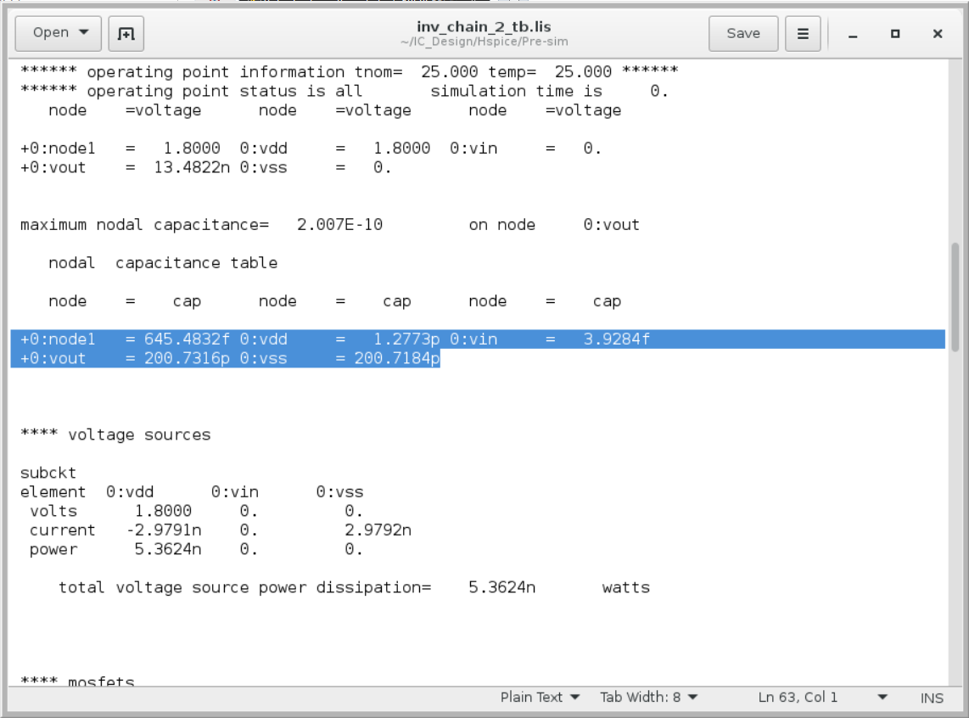

C(total) = Cin + Cout + Cnode1

= 645.4832f + 3.9284f + 200.7316p

= 201.3810pF

P = CV2f = 201.3810p * 1.82 * 50M = 32.6237mW

N = 3

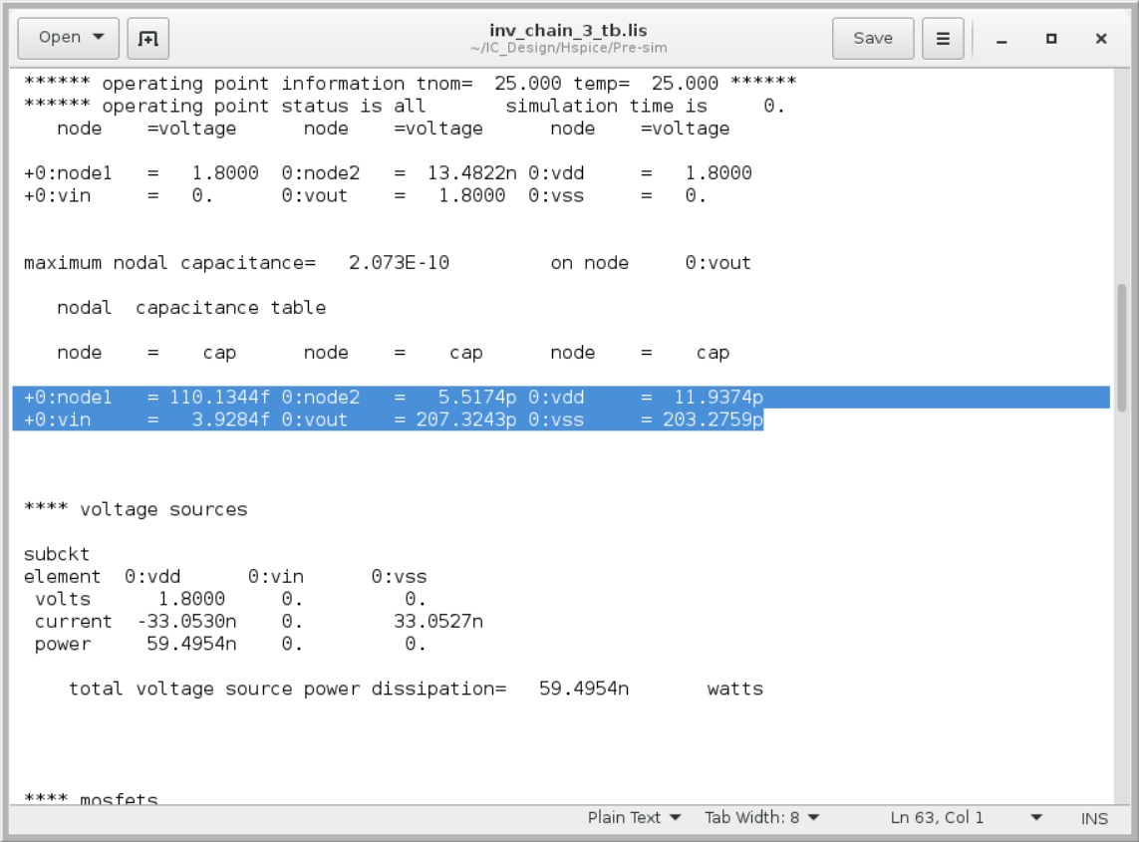

C(total) = Cin + Cout + Cnode1 + Cnode2

= 110.1344f + 5.517p + 3.9284f + 207.3243p

= 212.955pF

P = CV2f = 212.955p * 1.82 * 50M = 34.499mW

N = 4

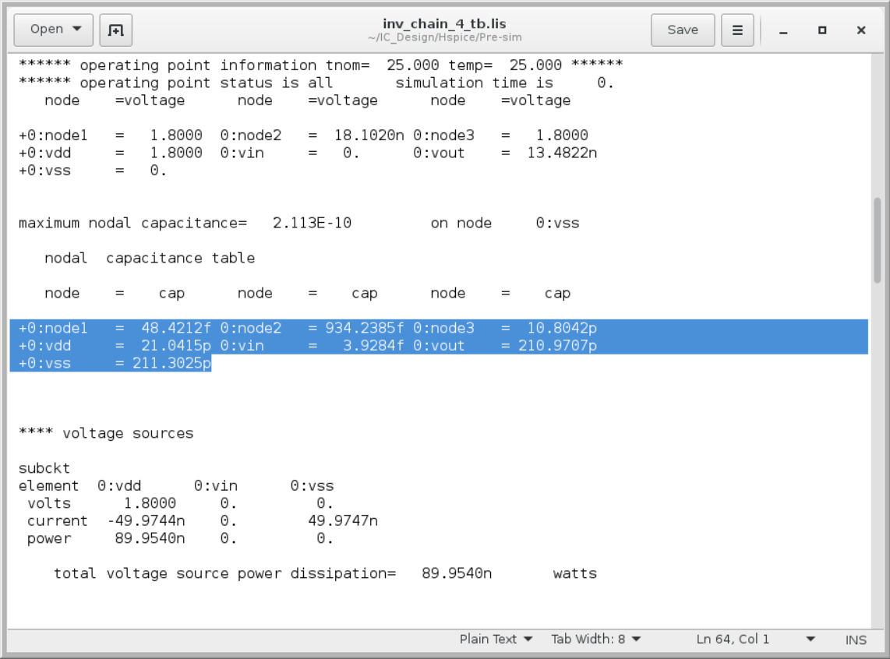

C(total) = Cin + Cout + Cnode1 + … + Cnode3

= 48.4212f + 934.2385f + 10.8042p + 3.9284f + 210.9707p

= 222.7615pF

P = CV2f = 222.76p * 1.82 * 50M = 36.0874mW

N = 5

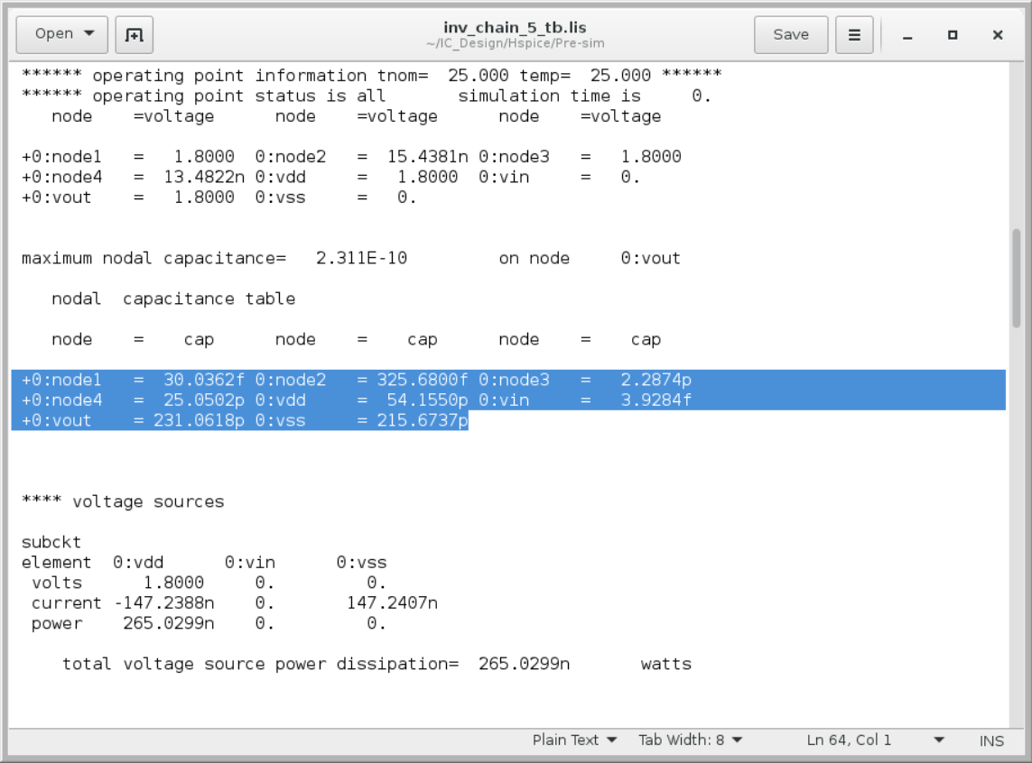

C(total) = Cin + Cout + Cnode1 + … + Cnode4

= 30.0362f + 325.6800f + 2.2874p + 25.0502p + 3.9284f + 215.6737p

= 243.3709pF

P = CV2f = 243.3709pF * 1.82 * 50M = 39.3719mW

N = 6

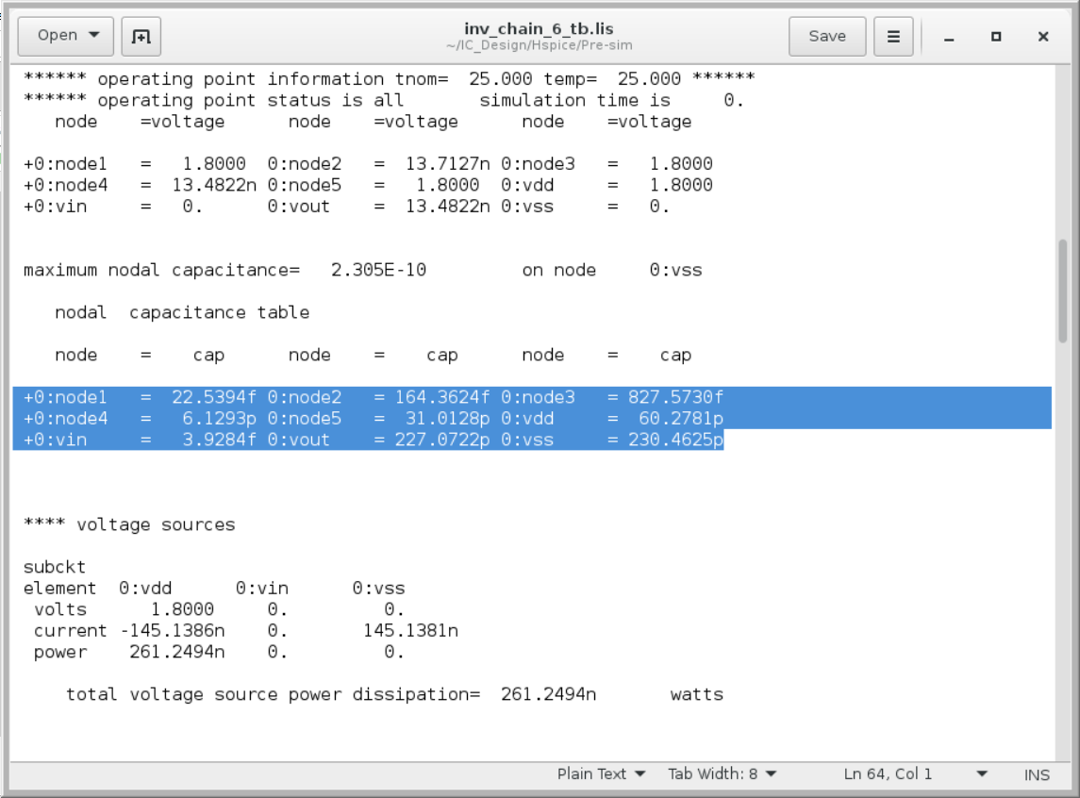

C(total) = Cin + Cout + Cnode1 + … + Cnode5

= 22.5394f + 164.3624f + 827.5730f + 6.1293p + 31.0128p + 3.9284f + 227.0722p

= 265.2327pF

P = CV2f = 265.2327pF * 1.82 * 50M = 42.9677mW

N = 7

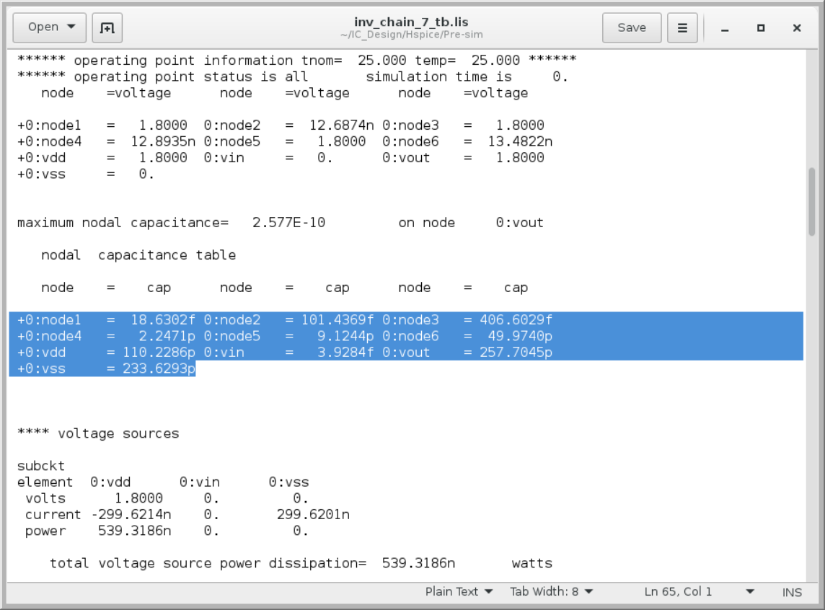

C(total) = Cin + Cout + Cnode1 + … + Cnode6

= 18.6302f + 101.4369f + 406.6029f + 2.2471p + 9.1244p + 49.9740p + 3.9284f + 257.7045p

= 319.5806pF

P = CV2f = 319.5806pF * 1.82 * 50M = 51.7721mW

N = 8

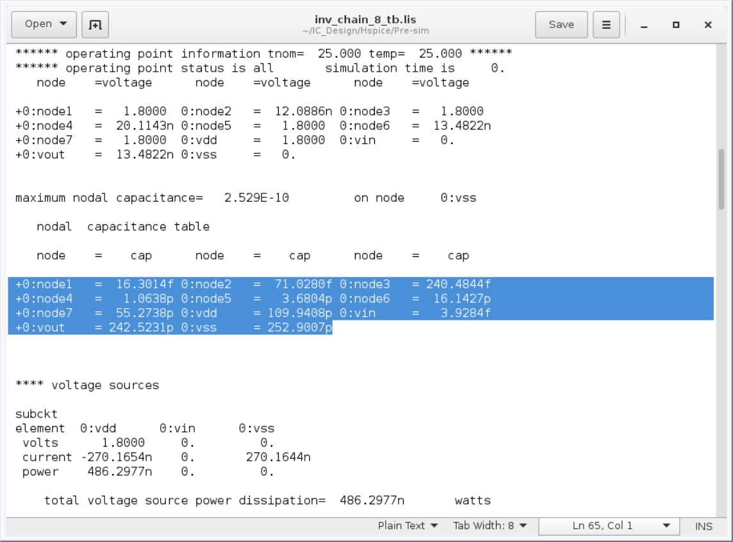

C(total) = Cin + Cout + Cnode1 + … + Cnode7

= 16.3014f + 71.0280f + 240.4844f + 1.0638p + 3.6804p + 16.1427p + 55.2738p + 3.9284f + 242.5231p

= 319.0155pF

P = CV2f = 319.5806pF * 1.82 * 50M = 51.6805mW

N = 9

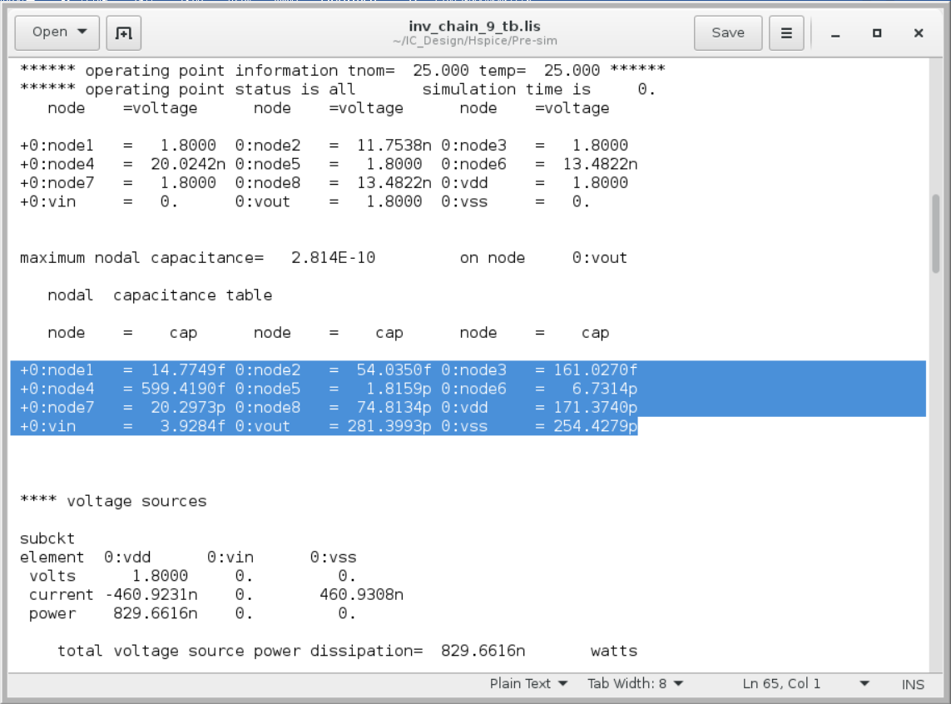

C(total) = Cin + Cout + Cnode1 + … + Cnode8

= 14.7749f + 54.0350f + 161.0270f + 599.4190f + 1.8159p + 6.7314p + 20.2973p + 74.8134p + 3.9284f + 281.3993p

= 385.8905pF

P = CV2f = 385.8905pF * 1.82 * 50M = 62.5143mW

N = 10

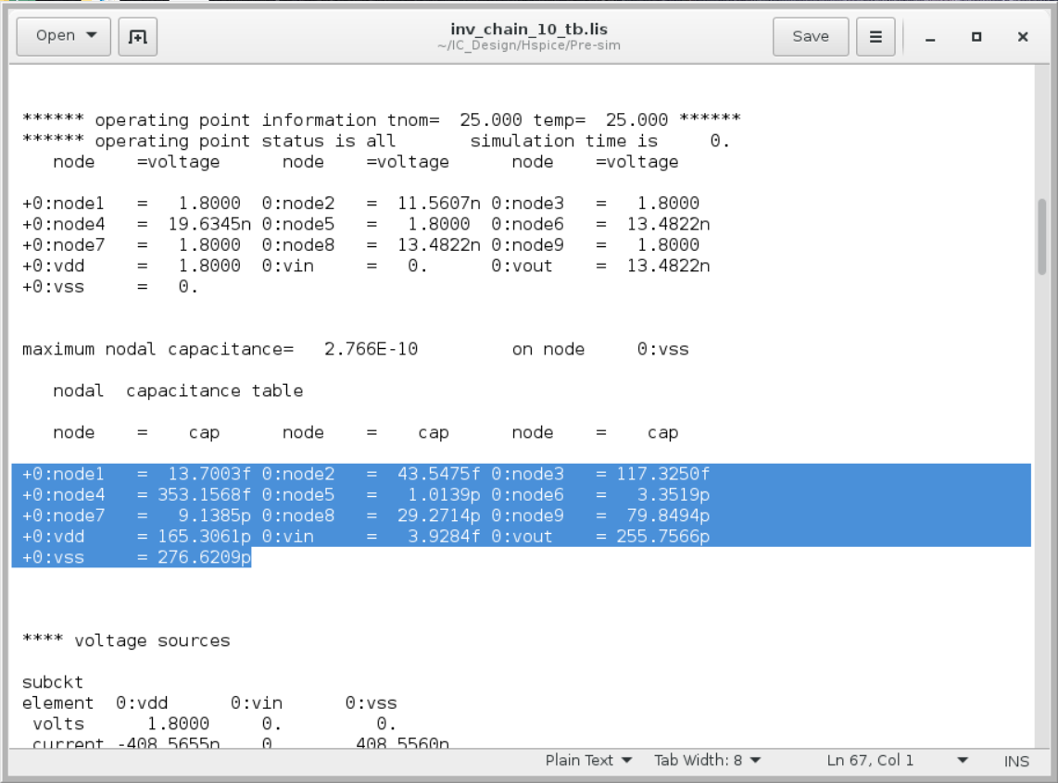

C(total) = Cin + Cout + Cnode1 + … + Cnode9

= 13.7003f + 43.5475f + 117.3250f + 353.1568f + 1.0139p + 3.3519p + 9.1385p + 29.2714p + 79.8494p + 3.9284f + 255.7566p

= 378.8698pF

P = CV2f = 378.8698pF * 1.82 * 50M = 61.377mW

2.(b)

In 1(b), 可得知，when D = 28.49, delay = 454.0129p，因此可推得下表

|  |  |  |  |
| --- | --- | --- | --- |
| N | f | D | delay(ps) |
| 1 | 50911.31249 | 50912.31249 | 811331.9284 |
| 2 | 225.6353529 | 453.2707059 | 7223.262466 |
| 3 | 37.06278905 | 114.1883672 | 1819.690829 |
| 4 | 15.0211635 | 64.08465401 | 1021.244634 |
| 5 | 8.73701052 | 48.6850526 | 775.8386072 |
| 6 | 6.087921571 | 42.52752942 | 677.7131261 |
| 7 | 4.703293078 | 39.92305154 | 636.2085085 |
| 8 | 3.875714579 | 39.00571664 | 621.5899799 |
| 9 | 3.334105715 | 39.00695143 | 621.6096574 |
| 10 | 2.955843453 | 39.55843453 | 630.3980197 |

2.(c)

|  |  |  |  |  |
| --- | --- | --- | --- | --- |
| N | tpdf | tpdr | power | product |
| 1 | failed | failed | 360.1865u | Not defined |
| 2 | 5.8353n | 5.5720n | 34.1732m | 194.9120f |
| 3 | 1.6348n | 1.6118n | 36.6340m | 59.4680f |
| 4 | 988.5902p | 923.5510p | 39.4466m | 37.7137f |
| 5 | 749.4367p | 752.1306p | 43.8472m | 32.9198f |
| 6 | 667.4663p | 656.5623p | 48.3595m | 32.0147f |
| 7 | 629.8820p | 630.8910p | 53.9929m | 34.0364f |
| 8 | 626.2285p | 607.4136p | 58.9928m | 36.3897f |
| 9 | 622.0113p | 621.3121p | 65.1725m | 40.5152f |
| 10 | 694.6714p | 627.3033p | 70.4994m | 46.5992f |

When N=6, it has minimum “power-delay product”. And it is smaller than the number of stages for the shortest propagation delay, which is N = 8 in Q2b. 這可能是因為在N=5~10時delay都差不多，而power則是隨著N慢慢上升，兩者平衡之下N=6便為最佳解。

2.(d)

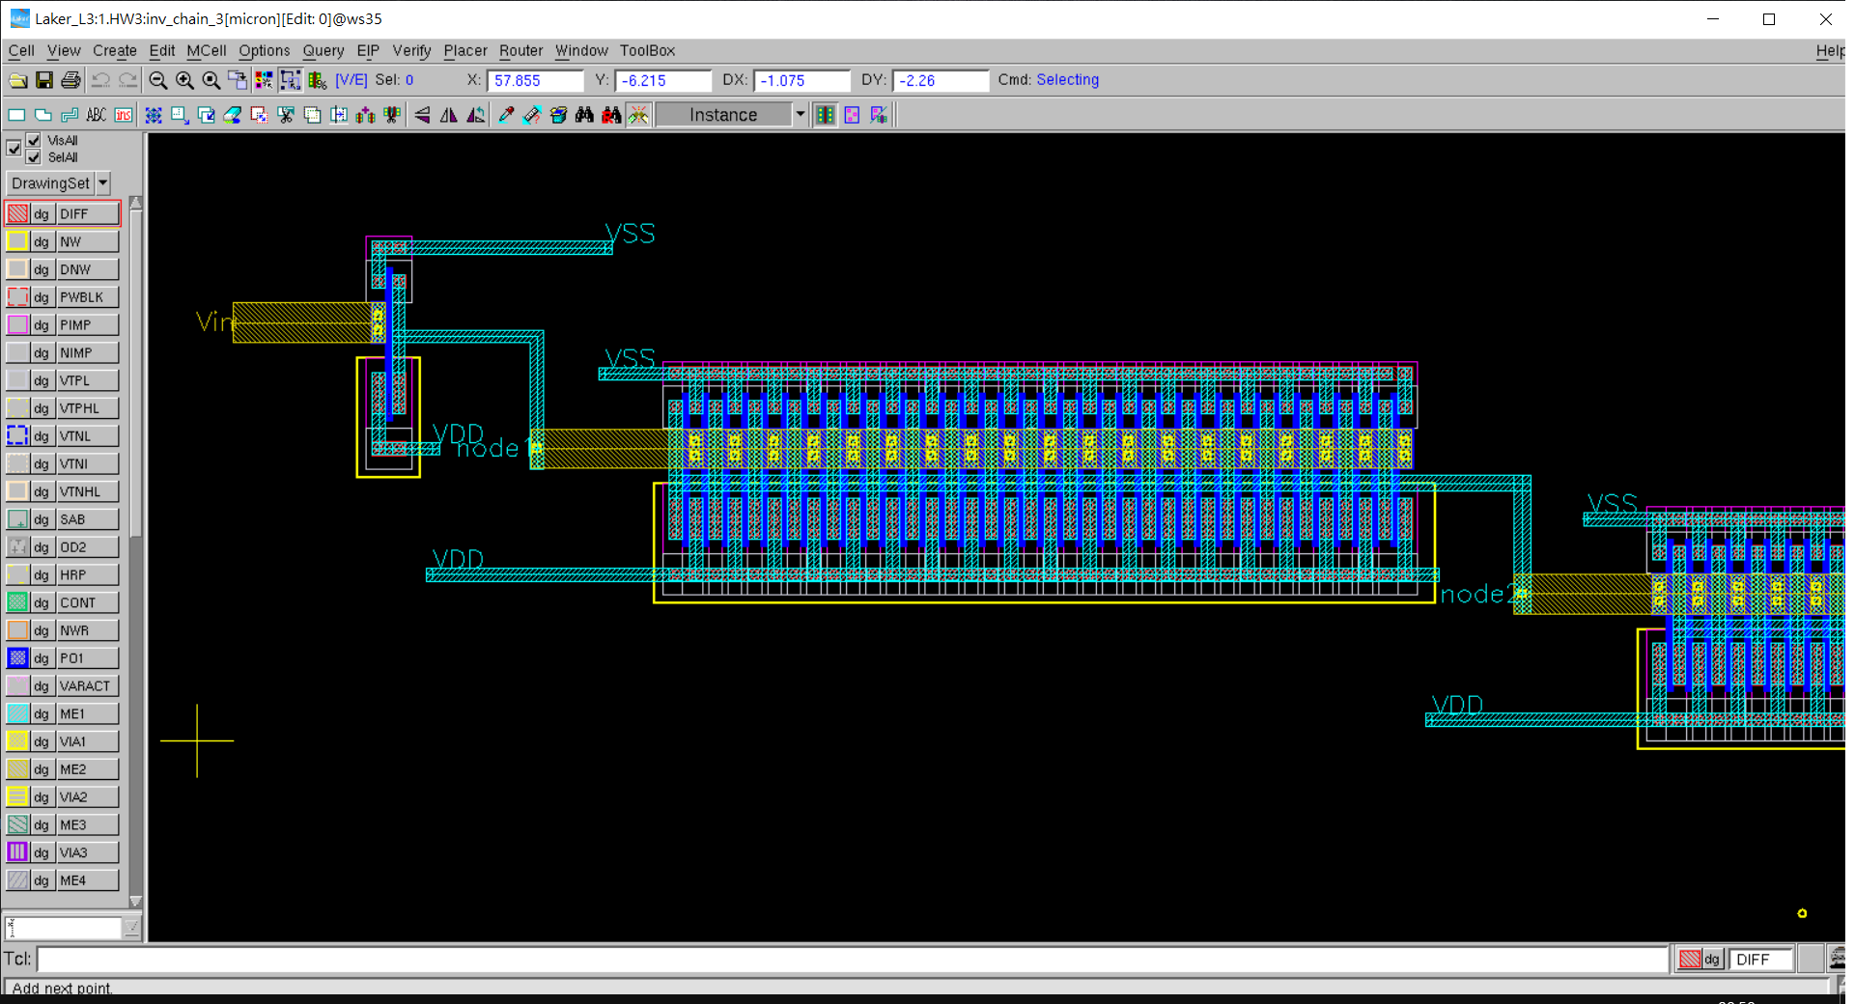

Layout

DRC

LVS

我有將inverter翻轉再合併，以共用metal, contact, and Diffusion；共用Diffusion可以降低delay

in2(c), power = 59.4680f, tpdf = 1.6348n, tpdr = 1.6118n

At here, power = 17.8572, tpdf = 3.5468n, tpdr = 8.9746n

我們可以觀察到power減少為1/3，但delay卻放大很多倍。我覺得主要跟我的layout方式有關，有可能我這樣layout讓許多MOS不用因此開開關關，讓 α 降低。但也因此要等其他MOS處理完才能運算，所以delay也增加許多